LAB Logbook

Lab 1:

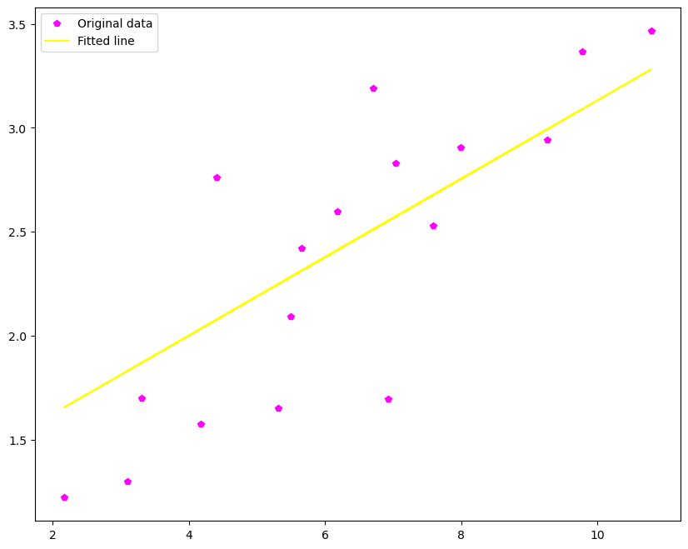

Lab 2

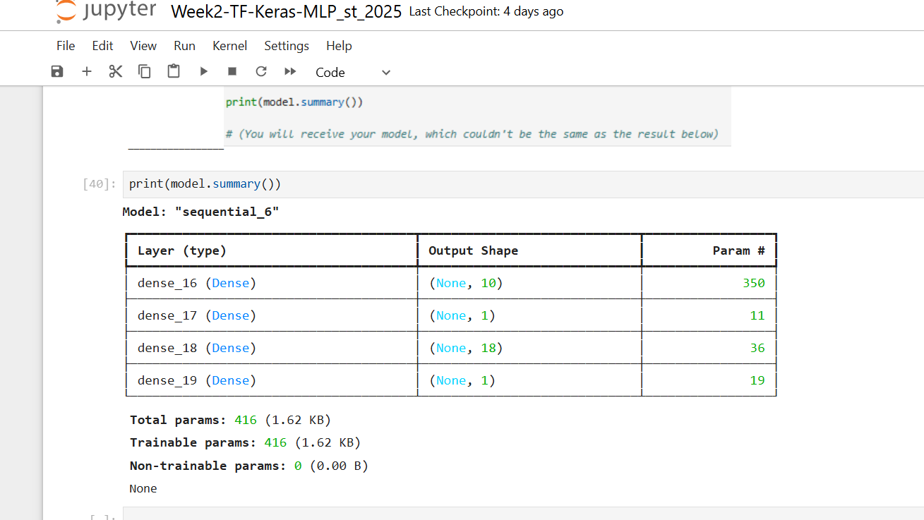

Accuracy: “0.862”

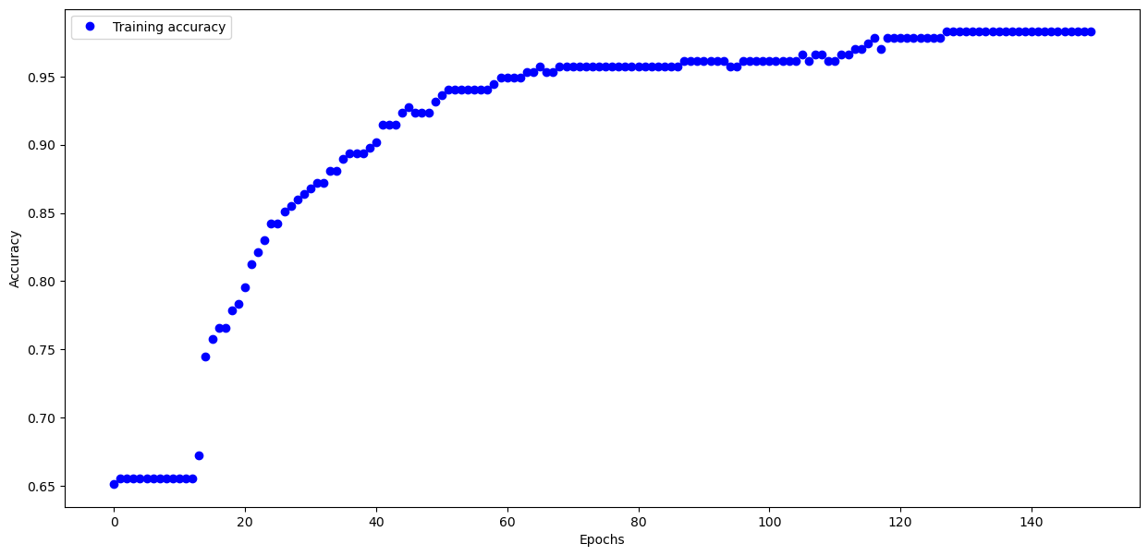

Lab 3

Test accuracy: 0.8953999876976013

Model summary:

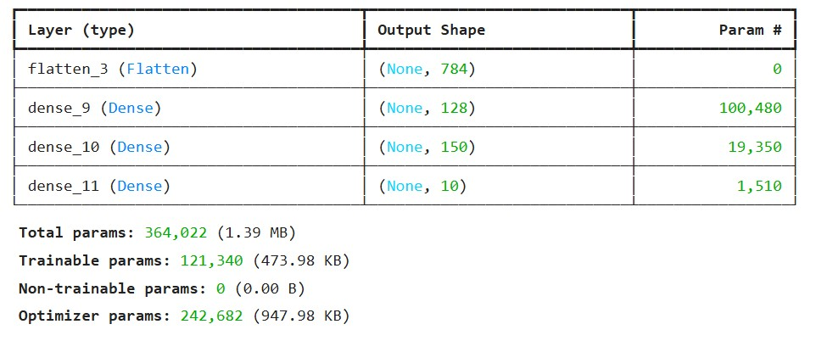

Lab 4

Lab 5

Lab 6

Lab 7

Lab 8

Lab 9

Lab 10

Lab 11

Lab 12